TOP TIPS…

Mark making and writing should be fun.
Encourage your child to ‘pretend’ to write as this is how their writing emerges naturally.
*It is important to develop your child’s arm and hand muscles and their fine motor control ready for later writing.
*Follow what your child is interested in and use this to support their mark making. For example, if they love cars, make number plates and make maps.
*Find real-life opportunities to write—e.g. shopping lists for the supermarket run.
Remember that children develop at their own rates.
*Value and praise is a really important part of any child’s development. Value and praise all of their marks—drawing, pretend writing, muddled up letters and more clear writing are all valuable!
*Mark make both inside and outside.
*Encourage your child to explore with all of their senses so they can feel the letters as well as see them.

If you have any questions on how to support your child outside of school, please come and speak to us.
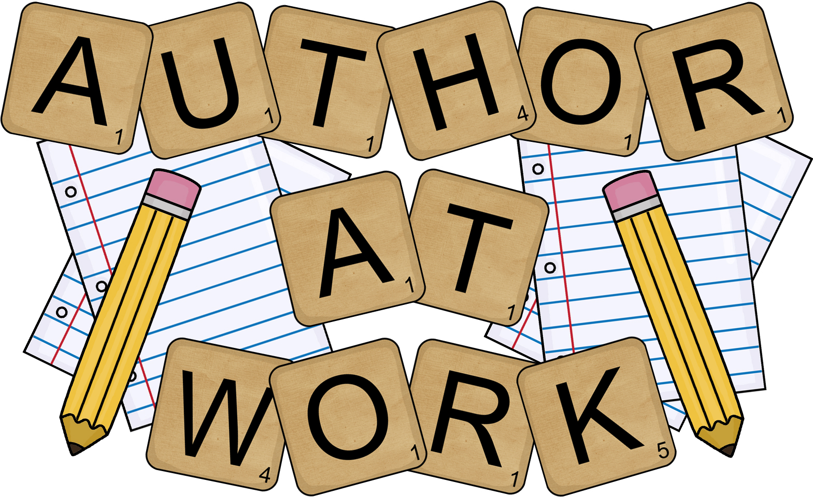
Parent Information Leaflet

