Early Years Writing boxes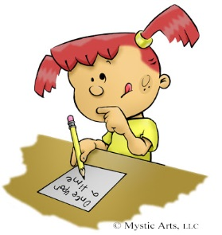
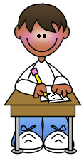

Dear Parents and Carers,

If you want to change the world, pick up your pen and write.
Martin Luther King

One of our amazing children had a brilliant idea! They decided to make themselves a writing box in which they put a variety of equipment that could support their writing but better still… it was portable and they could take it anywhere in the Early Years classroom just incase they needed to do some writing.

Soon, everyone wanted one so we decided we would take this brilliant idea and they could all make their own, choosing their own style of cover by using wrapping paper. We put into our boxes lots of different equipment which they could use at home to practise their writing.

We are constantly encouraging our children in Early Years to take part in activities which help them to become young writers and to enjoy the many ways in which you can do this.

Therefore, we would like to invite parents at home to create a similar writing box for children to use at home.

Ideas for writing equipment we usually put into these boxes are pencils, pens, colouring pencils, crayons, paper, rulers, paint brushes, rubber, pencil sharpeners, note pad and anything else you think would be good to use.
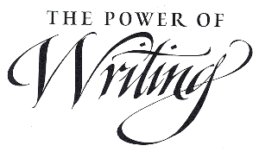

Children have been thrilled to use theses boxes at home
and at school. We hope you have fun creating it and
becoming a writer.

