|  |
| --- |
|  |

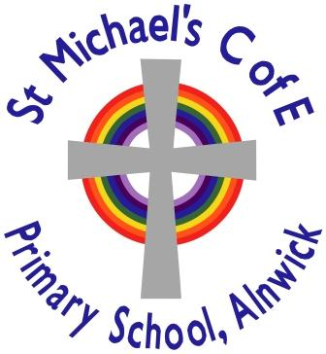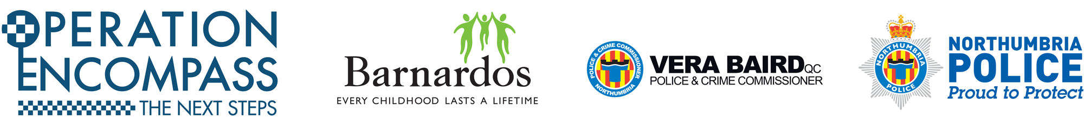

Laura Miller from

Operation Encompass ‘the next steps’ will be in school on **Monday 11th November**.

She will be hosting a drop-in session and will be available from **8.30am – 9.15am** to discuss any concerns.